Anthony Redamonti

Syracuse university

Project 3

CSE 681 Software modeling & analysis

prof. gregory wagner

9/2/2022

Introduction

The following project was written in C# targeting the .NET6 framework in Visual Studio 2022 IDE. The goal of the project is to send *REST get* requests to a collection of https addresses to collect JSON data. The data is converted to JSON object form and displayed to the GUI as team name and the record for the 2020 season. Below is a class flowchart. Please download the Newtonsoft.Json package. In Visual Studio, click Project > Manage NuGet Packages. Search for “json.” The list of packages should include “Newtonsoft.Json” by James Newton-King.

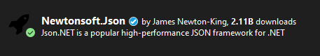

Class Flowchart of NflData.cs file:

TestFunctionality

WebClient

SeasonInfo

Utility

GameInfo

VisTeamStats

HomeTeamStats

Class Flowchart of MainWindow.xaml.cs file:

MainWindow

TestFunctionality

NflData.cs: TestFunctionality System Flowchart

Response: JSON data (string)

TestFunctionality https://sports.snoozle.net/...teamName=1 Internet

Class Request Response  
 JSON data (string)

API for online web server connected to a database.

MainWindow.xaml.cs System Flowchart

MainWindow Class

1 2 3 4

Collect Data Thread Display Data Thread

Run the TestFunctionality class’s Extract the data from the JSON   
 collectData method. object. Display it to the GUI.

GUI Design & System Behavior:

The following GUI was created using a XAML C# project.

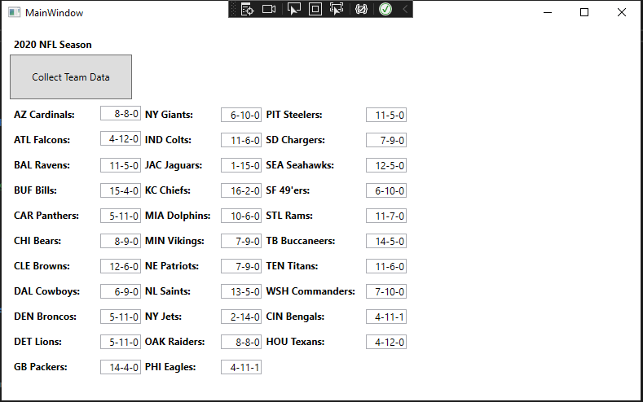

Project 3 contains a file “NflData.cs” and “MainWindow.xaml” inside its namespace. NflData.cs contains the contents from Project 2 (TestFunctionality class, etc.). The MainWindow.xaml.cs code composes an instance of the TestFunctionality class and displays its JSON object data to the GUI.

1. The user presses the “Collect Team Data” button.
2. The button event handler will start the collectData thread and wait for it to finish (join).
3. The collectData thread will call the collectData method on the instance of the testFunctionality class.
4. The testFunctionalityObj sends a series of REST get requests targeting the API of an online server using a specific https address and deserializes a series of JSON objects inside a list.
5. The collectData thread returns. The testFunctionalityObj now contains the list of JSON objects in the form of the SeasonInfo class.
6. The button event handler will start the displayData thread and wait for it to finish (join).
7. The displayData thread will extract the JSON object data from the list and compare the team name of each entry. If the team name matches the name in a predefined array of strings, the team record is displayed in the GUI.
8. The displayData thread returns. The button event handler returns.

Code

The code comprising the project 3 namespace is distributed in three files: NflData.cs, MainWindow.xaml, and MainWindow.xaml.cs. The files are attached to the project submission.